Check-In

Row No.: 33

|  |  |  |  |  |
| --- | --- | --- | --- | --- |
| **Description** | **Test Steps** | **Expected Output** | **Status** | **Comments** |
| Verify visitor badge includes all required information | 1. Complete visitor check-in process 2. View the generated visitor badge | Badge should display visitor name, host name, date, time, and any other required information | **Fail** | Visitor badge is not displayed |

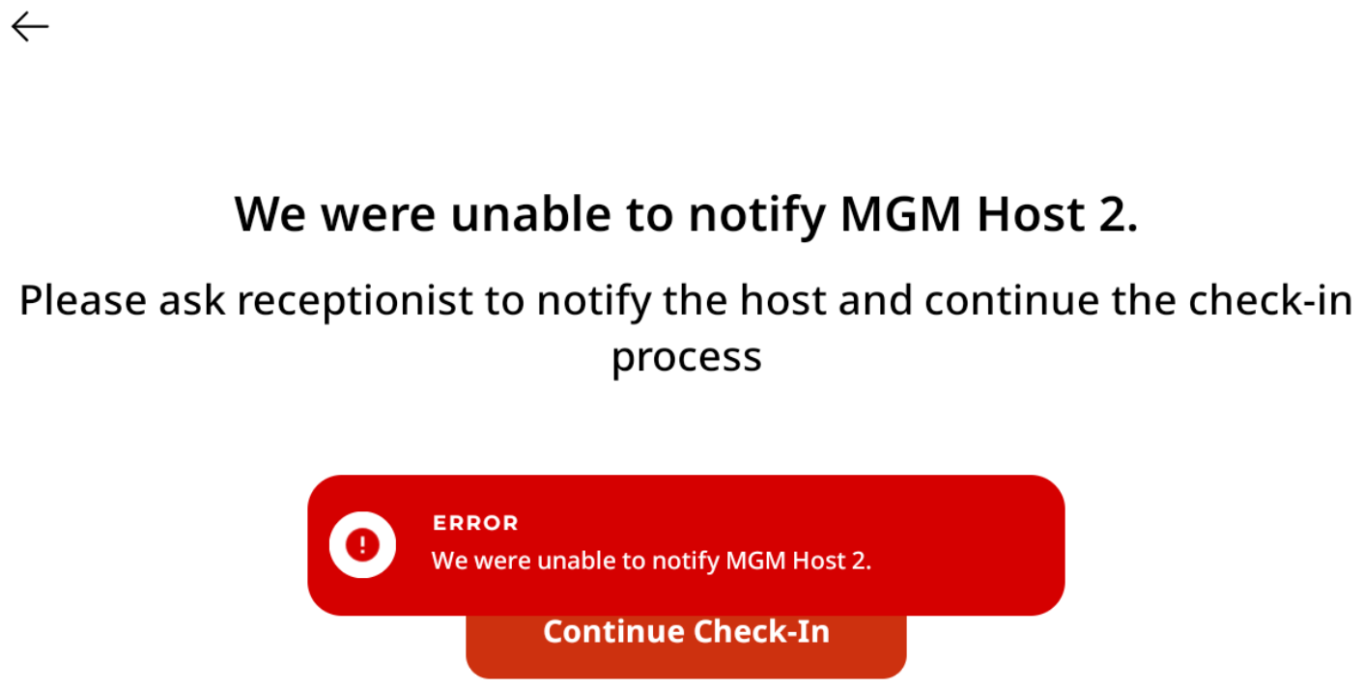

When Continue Check-In button is clicked, the following message gets displayed, instead of the visitor badge.